The Classroom Survey --Getting to Know You!

PART I. INTRODUCING THE CLASS

A. Name of teacher: Violeta Cozonac

B. Grade level: 9 grade

C. Class favorites (List your class top 5 favorites in each category):

1. Music groups Zdop și Zdup, 3 Sud-Est, Acord

2. Authors Ion Creangă, Grigore Vieru, Lucian Blaga, Mihai Eminescu

3. TV programs Comedy Club, The Door, Six Frameworks, Pepper

4. Foods Zeama, pizza, cabbage rolls (sarmale), barbecue, beans.

5. School subjects PE, history, English

6. Sports football, volleyball, basketball

7. Video or computer games War Face, Farm, Zombies

8. Favorite Websites facebook, odnoklassniki, youtube, google, instagram, skype, viber

9. Other Class Favorites of your choice

PART II. INTRODUCING THE SCHOOL

A. School information

1. Name and address of class and school. Public Institution Theoretic Lyceum ”Ion Creangă”, village of Cuizăuca, Rezina District, Republic of Moldova

2. Number of students in class and school. Our class has 14 students. There are 268 students in the school.

3. School emblem, colors or mascot. We do not have a mascot, but you can find our emblem

5. Type and number of computers.
In the school there are 12 PCs Pentium 4 and 5 laptops Lenovo. The PSs are used by the students at Computer Classes and laptops can be borrowed for the lessons by the teachers.

6. School history
The first school in the village was a primary one, which was founded in 1902 with only 4 grades. In 1961 it rose to rank of general secondary school with 11 grades, and after that with 10 grades. Since 1987 it passes in the general secondary school with 11 grades then maintained this position until 2003.
The school gets the status of Theoretic Lyceum on 13th of August 2003, this means it has 12 grades. In December 2013 the school becomes a Public Institution, this status gives it the permission of self-financing.

B. School program

- List 3 things about your school program that make it unique.
The school day starts at 8:30 in the morning. All the lessons are of 45 minutes, between each one there is a 10 minutes break. There are two brakes of 15 minutes when the pupils from the primary levels eat at the canteen, their lunch is financed by the government, the rest of the student bring home made lunches or buy smth from nearby shops. The major part of the pupils have lessons till 2:00 pm after that they have the possibility to choose a club: dance club, handicrafts club, chess club, volleyball club.

2. List school calendar from the session dates (holidays and special
events that may affect your participation).
Autumn Break – October, 29 – November, 01
Winter Holidays – December, 25 – January, 10
Spring Break – March, 04 – March, 08
Easter Holydays – April, 30 – May, 09
Summer Vacation – June, 01 – August, 31

PART III. INTRODUCING THE COMMUNITY

A. Your community

1. Name of your community Village of Cuizăuca

2. If not a city, name and size of nearest city. Rezina

3. Location of your community. It is situated in the South-East of Europe

4. The area of your community 1.75 square kilometers

5. The population of your community 1 425 people

B. Special characteristics

- List 3 reasons why people come to visit your area.
Our aria has some of the Moldovian touristic places as Saharna Monastery, Rocky Monastery near Țipova and the bank of the biggest river in Moldova Nistru River

C. Industries
The major occupation in our community is cattle breeding, gardening and apple, plum orchards.

PART IV. OTHER INFORMATION

On September, 01 we hold the Knowledge Day. It is the first school day.

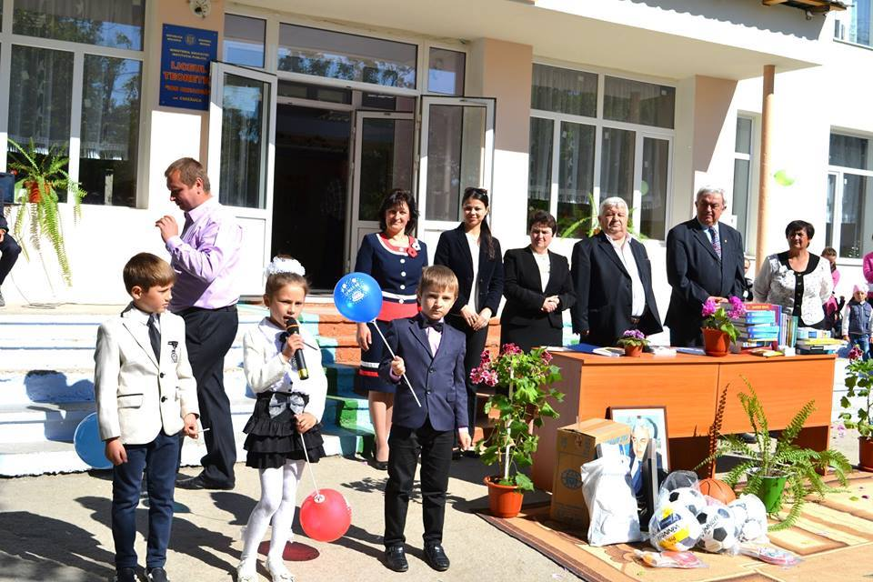

Every year on March, 01 we celebrate our School Day. It is the birthday of our Patron Ion Creangă, a beloved children’s writer.

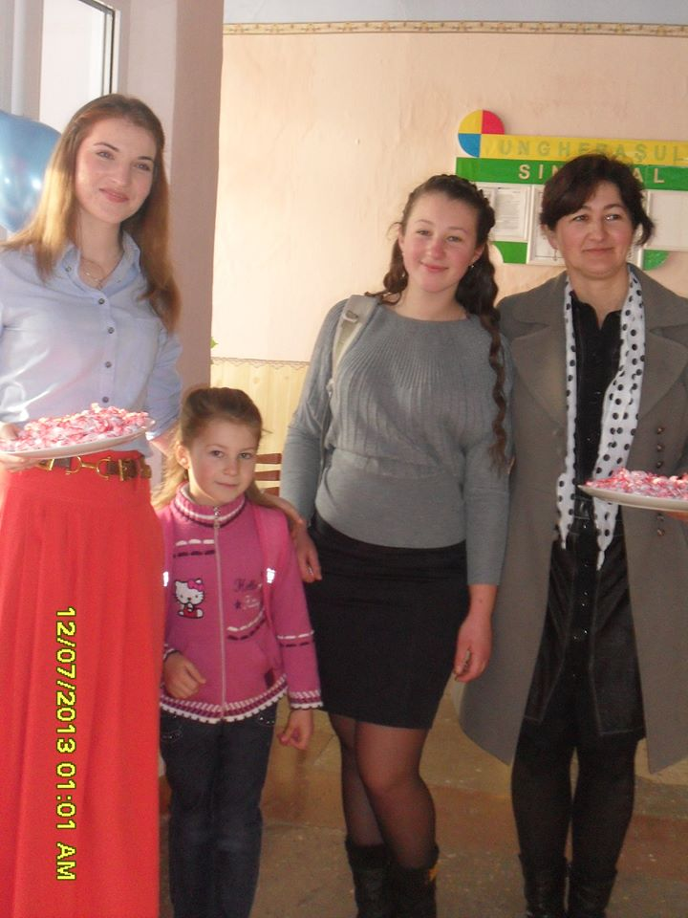
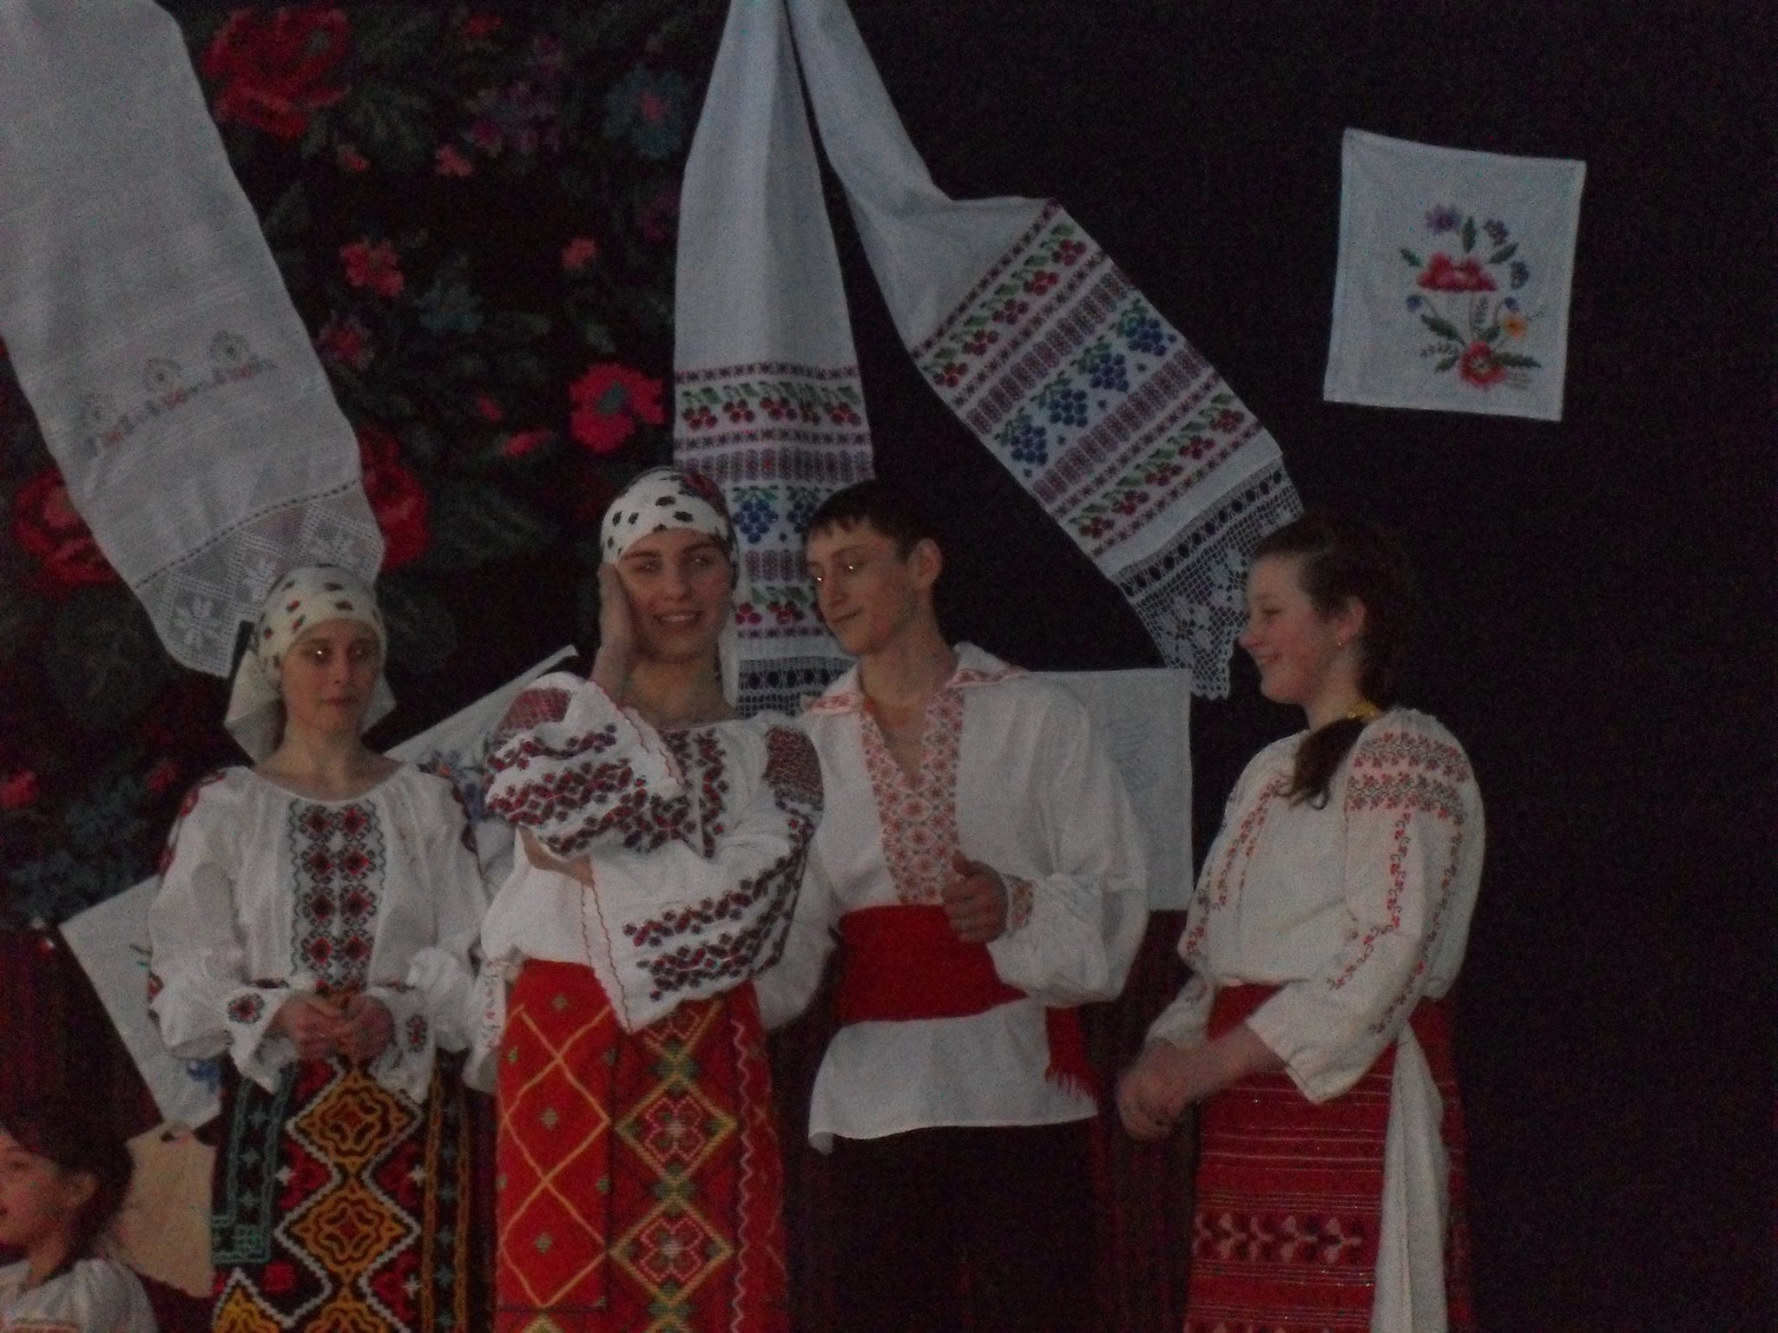

Also we have introduced Students Day, it is hold the last day before the Autumn Break. In this day all the students got candies at the school entrance.

During Christmas Holidays we love to sing carols. 

